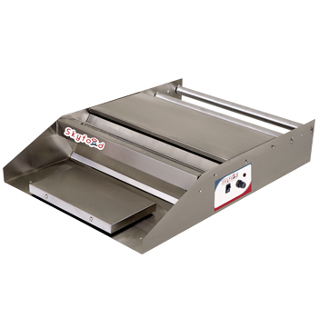
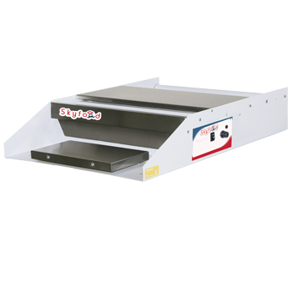

HTSW Heat Seal Wrapper HTSWL Heat Seal Wrapper
$ 318.00 (Esta a $ 270.00) $ 454.00 (esta a $ 385.00)

• Our Heat Seal Wrapper is an essential piece of equipment in any grocery stores, food markets, bakeries and other food operations for quickly and easily wrapping your food products for storage or display.
• Model HTSW features steel structure with electrostatic oven paint and anti corrosion coating and model HTSWL is all made in stainless steel.
• Both units feature polished stainless steel wrapping surface for quick and easy clean up.
• Adjustable temperature control
• Use up to 18” wide shrink wrap rolls
• Hot rod cut off bar with safety guard protects user from coming in contact with the hot bar.

Item | Voltage | Amps. | Dimensions  (W x D x H) | Net  Weight | Shipping  Weight | Hot Seal  Plate | Max Film  Width
HTSW | 110V | 1.65 | 21.6”x25.2”x5.5” | 19.6lb | 27.2lb | 5” x 10” | 18”
HTSWL | 110V | 1.65 | 21.6”x25.2”x5.5” | 16.7lb | 25.7lb | 5” x 10” | 18”
